**Integrated Space Station OS**

**System Requirement Specification (SRS)**

SSOS-2025003

Space Station OS Project

Revision NC

REVISION AND HISTORY PAGE

|  |  |  |  |
| --- | --- | --- | --- |
| 1. **Revision**  **No.** | 1. **Change**  **No.** | 1. **Description** | 1. **Release**  **Date** |
| 1. NC |  | 1. Initial Release 2. Documented by Hiroki Kato. | 1. 2025/1/X |
|  |  |  |  |
|  |  |  |  |
|  |  |  |  |

TABLE OF CONTENTS

1.0 INTRODUCTION 4

1.1 Purpose 4

1.2 Applicable Documents 4

1.3 Relavant Documents 4

2.0 Premise 5

2.1 Term definition 5

2.2 Actors 6

2.3 Lifecycle 6

2.4 Operational use cases 1

2.4.1 Development of space station utilizing Integrated SSOS 1

2.4.2 Operation of space station utilizing Integrated SSOS 1

2.4.3 Accepting a visiting vehicle to space station utilizing Integrated SSOS 2

2.5 Hypotheses 2

2.6 *strategic* use cases vs. *operational* use cases 2

3.0 Requirements Specification Description 3

3.1 Design 3

3.2 Top-Level Requirements Specification 3

3.3 Requirements Specification 4

3.3.1 SSOS GNC 4

# INTRODUCTION

## Purpose

1. This document describes System Requirement Specification (SRS, thereafter) for the "Integrated Space Station OS" (Integrated SSOS, thereafter). Integrated SSOS has already been made open source on github (<https://github.com/space-station-os>), and this document is intended to publicly communicate its mission design intention and requirements.

## Applicable Documents

1. Integrated Space Station OS mission statement (SSOS-2025001)

## Relavant Documents

1. GitHub <https://github.com/space-station-os>
2. Documentations <https://space-station-os.github.io/index.html>
3. Program <https://spacestationos.com/>

# Premise

1. In this section, we refer to *operational* use cases of SSOS after term and actor definitions. We first define the life cycle and the actors and then describe the operational use cases for each target user.

## Term definition

1. The following table defines terms describing regarding SSOS.
2. Table 2.1-1. Teams using in this document

|  |  |
| --- | --- |
| 1. SSOS | 1. Target for development. 2. Space Station OS, the target product to develop. It includes SSOS vehicle software, SSOS simulator, and SSOS ground station. ts design is described in Section 4.1, and requirements specification is described in Section 4.2. |
| 1. SS | 1. Space station(s) |
| 1. SS subsystem | 1. It may include electrical, mechanical, GNC, thermal, communication, ECLSS and visiting vehicle interface. Ground station is also included by context. |
| 1. OS | 1. Operating system |
| 1. SSOS vehicle software (SSOS software) | 1. Space Station OS software that simulates the dynamic behavior of hardware and the physics of the environment. It may be referred as SSOS software, and it may include SSOS ground station software by context. |
| 1. SSOS simulator | 1. Space Station OS software |
| 1. SSOS ground station | 1. Space Station ground station including software |
| 1. OSS | 1. Open Source Software (we use GitHub as of Jan. 2025) |
|  |  |
| 1. ISS | 1. International Space Station operating on orbit as of 2025 |
| 1. Visiting vehicle | 1. Visiting vehicle to SS, e.g., Crew Dragon, Soyuz, ATV, and HTV for ISS |
|  |  |
| 1. GNC | 1. Guidance Navigation Control |
| 1. EPS | 1. Electrical Power System |
| 1. ECLSS | 1. Environmental Control and Life Support System |
|  |  |
| 1. FDIR | 1. Fault Detection Isolation and Recovery |
|  |  |
| 1. SRS | 1. System Requirement Specification |

## Actors

1. The following table defines actors describing regarding SSOS.
2. Table 2.2-1. Actors describing SSOS

|  |  |
| --- | --- |
| 1. SS developer | 1. A group of engineers who develop SS. It may include SS system integrator, SS system tester, SS subsystem engineer. |
| 1. SS system integrator | 1. as name indicated |
| 1. SS system tester | 1. as name indicated |
| 1. SS subsystem engineer | 1. They include software engineers, electrical engineers, mechanical engineers, GNC engineers, thermal engineers, communication engineers, ECLSS engineers, and ground system engineer. |
| 1. SS software engineer | 1. as name indicated |
| 1. SS electrical engineer | 1. as name indicated |
| 1. SS mechanical engineer | 1. as name indicated |
| 1. SS GNC engineer | 1. as name indicated |
| 1. SS thermal engineer | 1. as name indicated |
| 1. SS communication engineer | 1. as name indicated |
| 1. SS ECLSS engineer | 1. as name indicated |
| 1. SS ground system engineer | 1. as name indicated |
| 1. SS operations director | 1. A person who creates and executes operational strategies, manages daily activities, and analyze performance to make necessary adjustments. |
| 1. SS ground operator | 1. A ground-based operator managing SS operations. These professionals are responsible for monitoring and controlling the spacecraft systems, ensuring the success and safety of the mission. |
| 1. SS visitor | 1. Visitor to SS, like ISS crew or traveler |
| 1. Visiting vehicle developer | 1. A group of engineers who develop a visiting vehicle for SS |
| 1. SSOS developer | 1. People developing Integrated SSOS from the SSOS project side. |
| 1. SSOS demo contributor | 1. People developing SSOS demos from the SSOS project side. (detail described in Section 3.1) |

## Lifecycle

1. In this subsection, we describe lifecycle of the Integrated SSOS.
2. Development of space station utilizing Integrated SSOS

SS developer chooses to utilize validated Integrated Space Station OS, and now it is a part of the space station development. Integrated SSOS supports their development.

1. Operation of space station utilizing Integrated SSOS
2. The space station with Integrated SSOS in it is now launched for flight operation. The Integrated SSOS provides user interface to the SS passengers as well as SS operation team for the SS operation lifetime.
3. Accepting a visiting vehicle to space station utilizing Integrated SSOS
4. Accepting a visiting vehicle to space station utilizing Integrated SSOS is a part of a space station operation. Is is a noteworthy event that will impact the interface of visiting vehicles and therefore their development
5. .
6. Development of Integrated Space Station OS

Four development phases are defined as seen in Figure 2.3-1. Since the initial version of the SSOS is released, we develop for ground-based version (Phase 2). After continuing development, the flight-demo version of SSOS software will be deployed for flight exposition (Phase 3). After successful flight demo, more SS business operators are expected to utilize SSOS (Phase 4).

Although we are still in Phase 2, this document scopes for flight software (Phase 3 and 4) unless it is notified.

In order to accelerate development of SSOS and to expand people’s contribution to the project, the SSOS project arranges the ground version of the SSOS so that contributors can component demo of functionalities. As illustrated in Figure 2.3-2, “Demo” programs are collected so that they could become a part of “Integrated” SSOS. Contributors may propose any one-shot short “demo” programs, implement, test and demo as they feel they are needed (Figure 2.3-3). They work as though they are unit/component tests of Integrated OS. Also, as Integrated SSOS development progress, a part of Integrated SSOS components could be used for SSOS demos.

This document covers Integrated SSOS, but not the SSOS Demo Program.

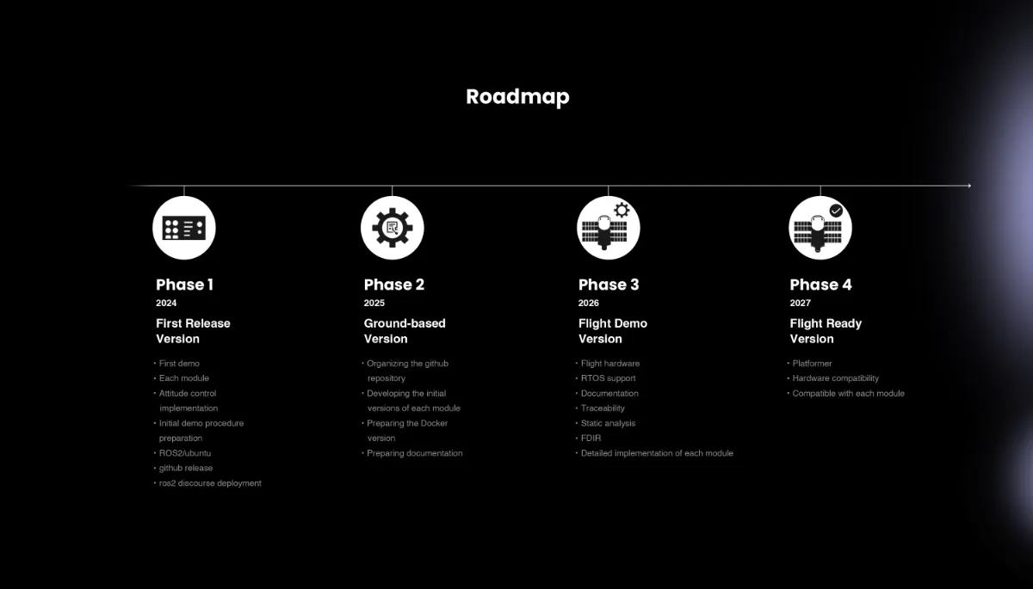

**Figure 2.3-1 Space Station OS Development phases**

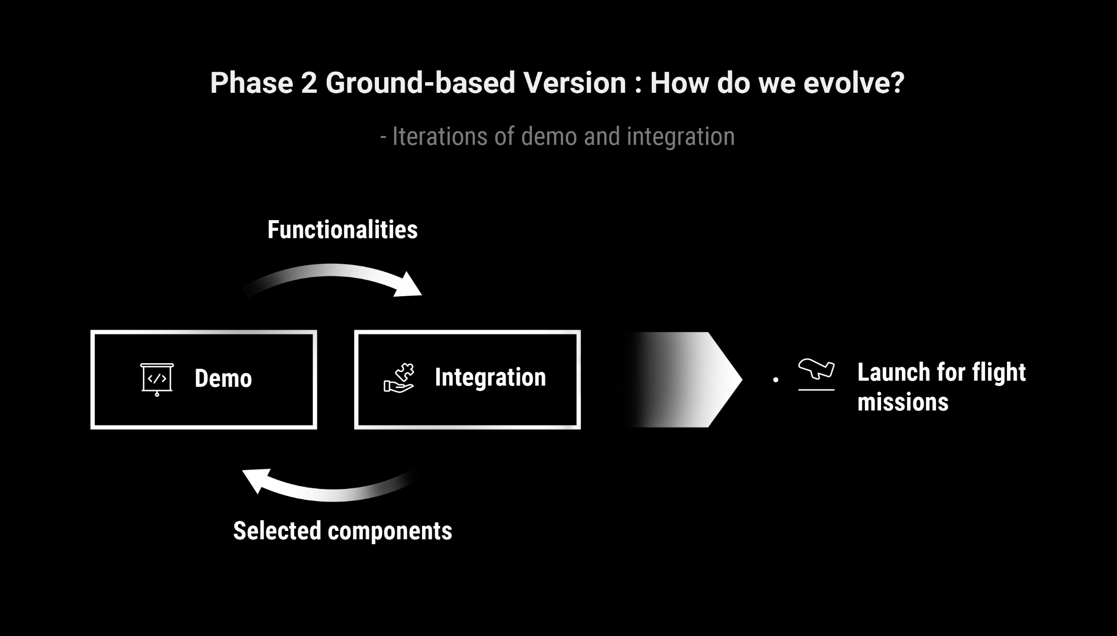 **Figure 2.3-2 Space Station OS, Demo and Integration scheme**

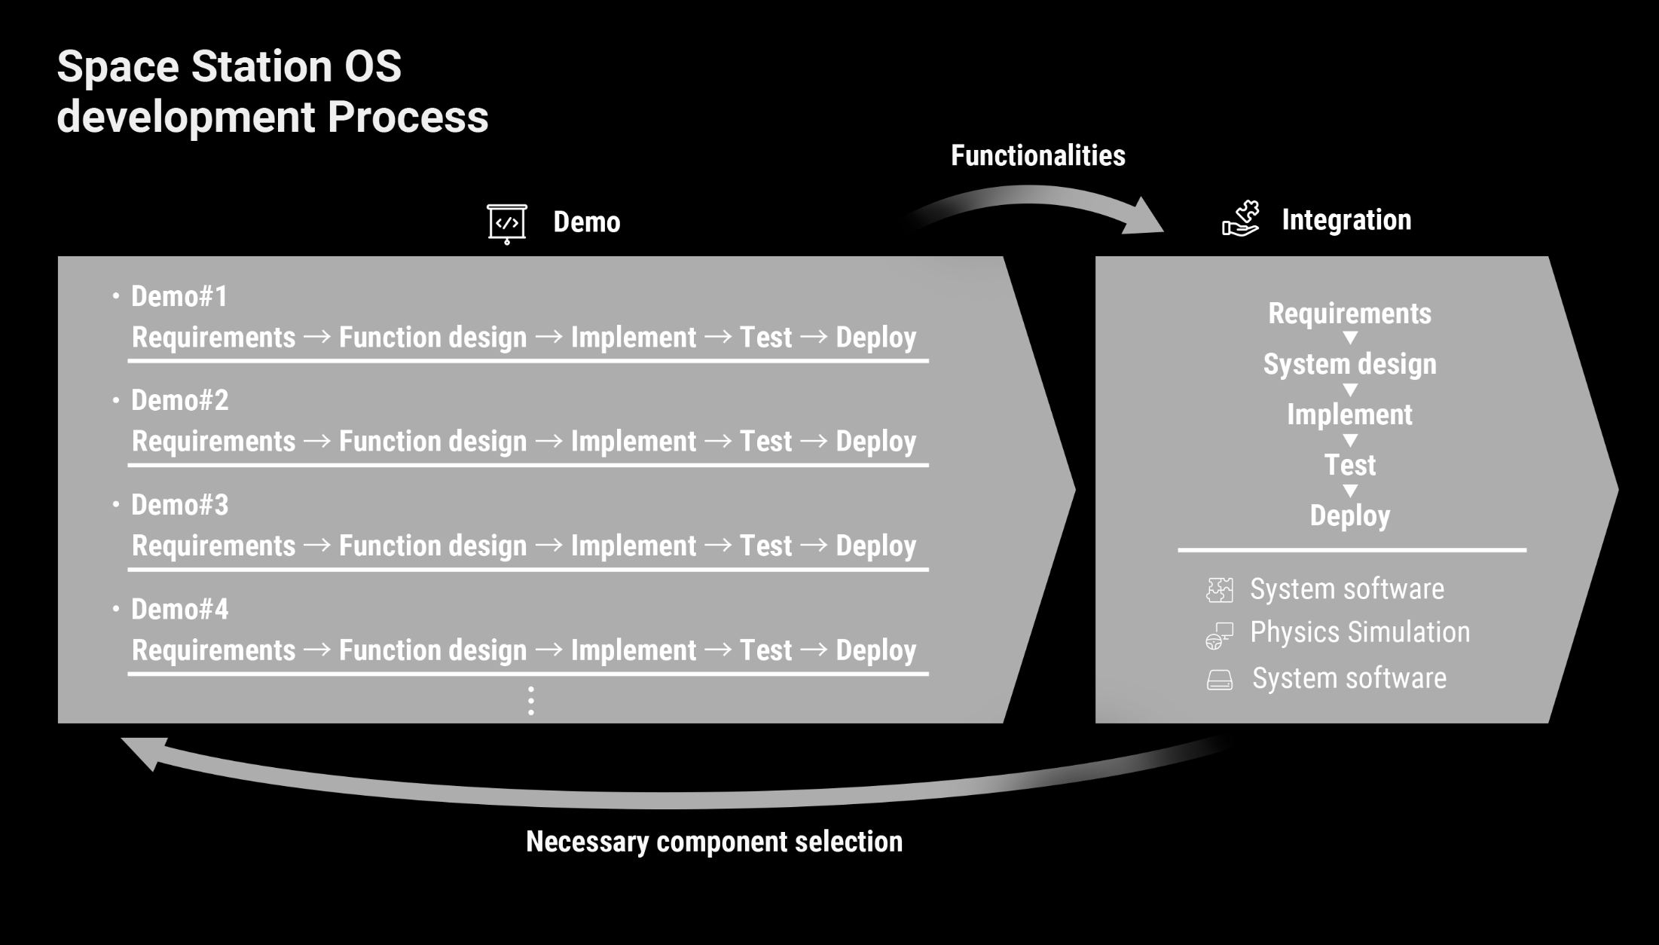

**Figure 2.3-3 Space Station OS, Demo and Integration scheme, detailed**

## Operational use cases

1. In this section, we describe the operational use cases of the Integrated SSOS. It is assumed that the integrated SSOS system design is as described in Section 3.1.

### Development of space station utilizing Integrated SSOS

1. SS developers use Integrated SSOS to integrate the subsystems, including hardware and software.
2. SS developers use Integrated SSOS to configure the subsystems, including accepting visiting vehicles that involves fuel mass change model and center of mass change.
3. SS developers use Integrated SSOS to simulate the subsystems.
4. SS developers test their FDIR by injecting fault scenarios with necessary configuration.
5. SS developers show interfaces to stakeholders including visiting vehicle developers that are defined by Integrated SSOS.
6. SS subsystem engineers use Integrated SSOS to design their subsystem where interfaces with necessary neighboring subsystems are simulated.
7. SS subsystem engineers operate the hardware that interfaces with the control implemented in Integrated SSOS. If necessary, they adjust configuration and interface for their hardware.
8. SS subsystem engineers perform simulations in which the simulation model is implemented after setting the required and desired configuration for control.

TODO: Specific use case for each subsystem

### Operation of space station utilizing Integrated SSOS

1. The space station with Integrated SSOS in it is now launched for flight operation. The Integrated SSOS provides user interface to the SS passengers as well as SS operation team for the SS operation lifetime.
2. SS operation directors use Integrated SSOS to design their flight operation timeline with acquiring necessary information and conducting simulations.
3. SS ground operators grasp necessary states of the space station and operation procedures that are displayed on the ground station (a part of Integrated SSOS).
4. SS ground operators send necessary direct commands and timeline command to the space station and timeline on Integrated SSOS.
5. SS ground operators are notified of space station malfunctions and respond appropriately.
6. SS visitors live in the space station that is maintained by Integrated SSOS.
7. SS visitors are notified of space station malfunctions and respond appropriately.

### Accepting a visiting vehicle to space station utilizing Integrated SSOS

1. Visiting vehicle developers interface the target space station whose interfaces ate defined Integrated SSOS. Thus, they acquire interface control specification through it.

## Hypotheses

1. In this section, we describe hypotheses of using SSOS.

TBD

## *strategic* use cases vs. *operational* use cases

1. In Document 1.2 (1), the *strategic* use cases of SSOS are defined. Whereas the strategic use cases are high-level, business-side, *operational* use cases described in this document defines technical and operational aspects of the product. Thus, the use cases as well as actors described in this document are more detailed for technical discussion later on.
2. Strategic use cases include non-functional requirements (NFRs), like the ones related to easing communication. They may not be explicitly included the SRS, but must be considered in the later development (requirements and implementations). Such strategic use cases include:
3. (TBD)

# Requirements Specification Description

## Tentative Design

Integrated SSOS consists of SSOS subsystems including GNC, EPS, Thermal, Communication and Ground System.

1. Integrated SSOS
2. ┣SSOS GNC  
   ┣SSOS EPS  
   ┣SSOS thermal  
   ┣SSOS communication  
   ┣SSOS ECLSS  
   ┗SSOS ground station

Figure 3.1 SSOS system composition

## Top-Level Requirements Specification

The top-level requirements for the SSOS are described in Section 3.2.1. The requirements for its subsystems are shown in Section 3.2.2 onwards.

TBD

1. SSOS shall …

Rationale: From Use Case (1). This is one of the top-level requirements that can be delivered based on the system's objectives.

1. SSOS shall … distribute contents of ROS 2 topics to the cFS system as cFS messages via Bridge Node as defined in Bridge Definer.

Rationale: From Use Case (X).

## Requirements Specification

The top-level requirements for the SSOS are described in Section 3.2.1. The requirements for its subsystems are shown in this section.

### SSOS GNC

1. SSOS GNC shall ….

Rationale:

# Scope

The SSOS project runs agile development so scope changes. The purpose is maintaining the scope of each iteration (usually runs for two to three months).

## Iteration #1 (Jan 13th – March 10th 2025)

ROS2 vehicle and simulation will be operational by summer to start conversations on hardware support.

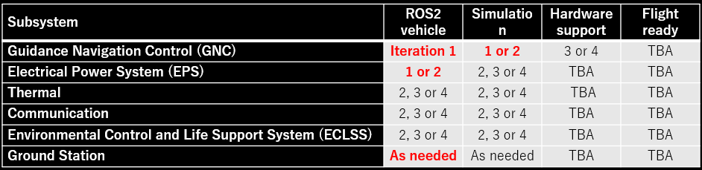

1. The goal of Iteration #1 is to implement and test GNC system for ROS2 vehicle software, to the extent possible within the prepared simulation environment.
2. Iteration #1 lasts till March 10th. (four 2-week sprints)

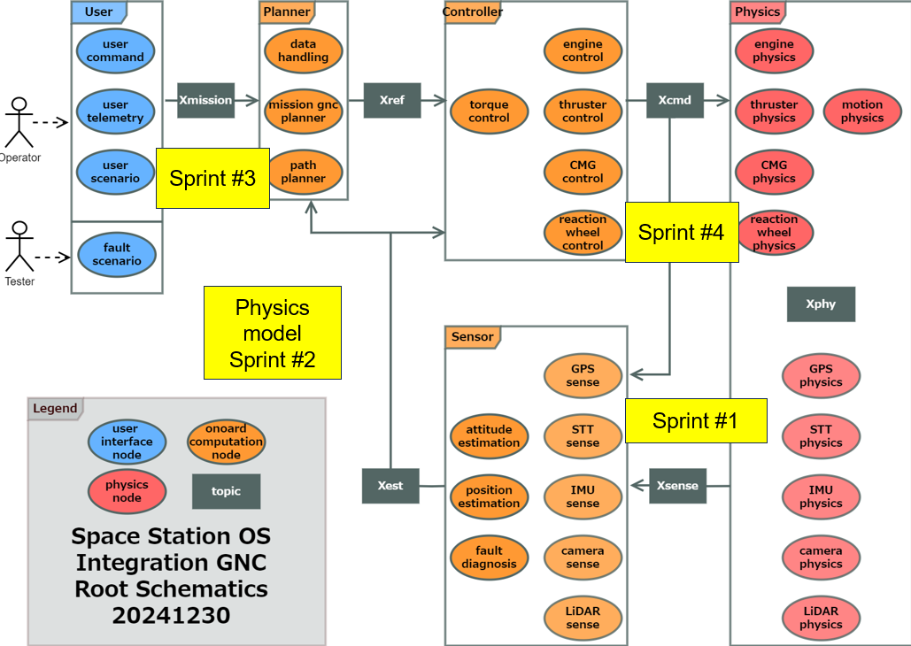

# System Design Specification

## (reserved)

## SSOS Subsystems

This section describes about SSOS subsystems that is defined in Document 1.2 (2) Section 3.1

### SSOS GNC

This section describes about SSOS GNC.

#### Block diagram

The figure below shows block diagram for the SSOS GNC system. Sub-blocks are defined in the diagram.

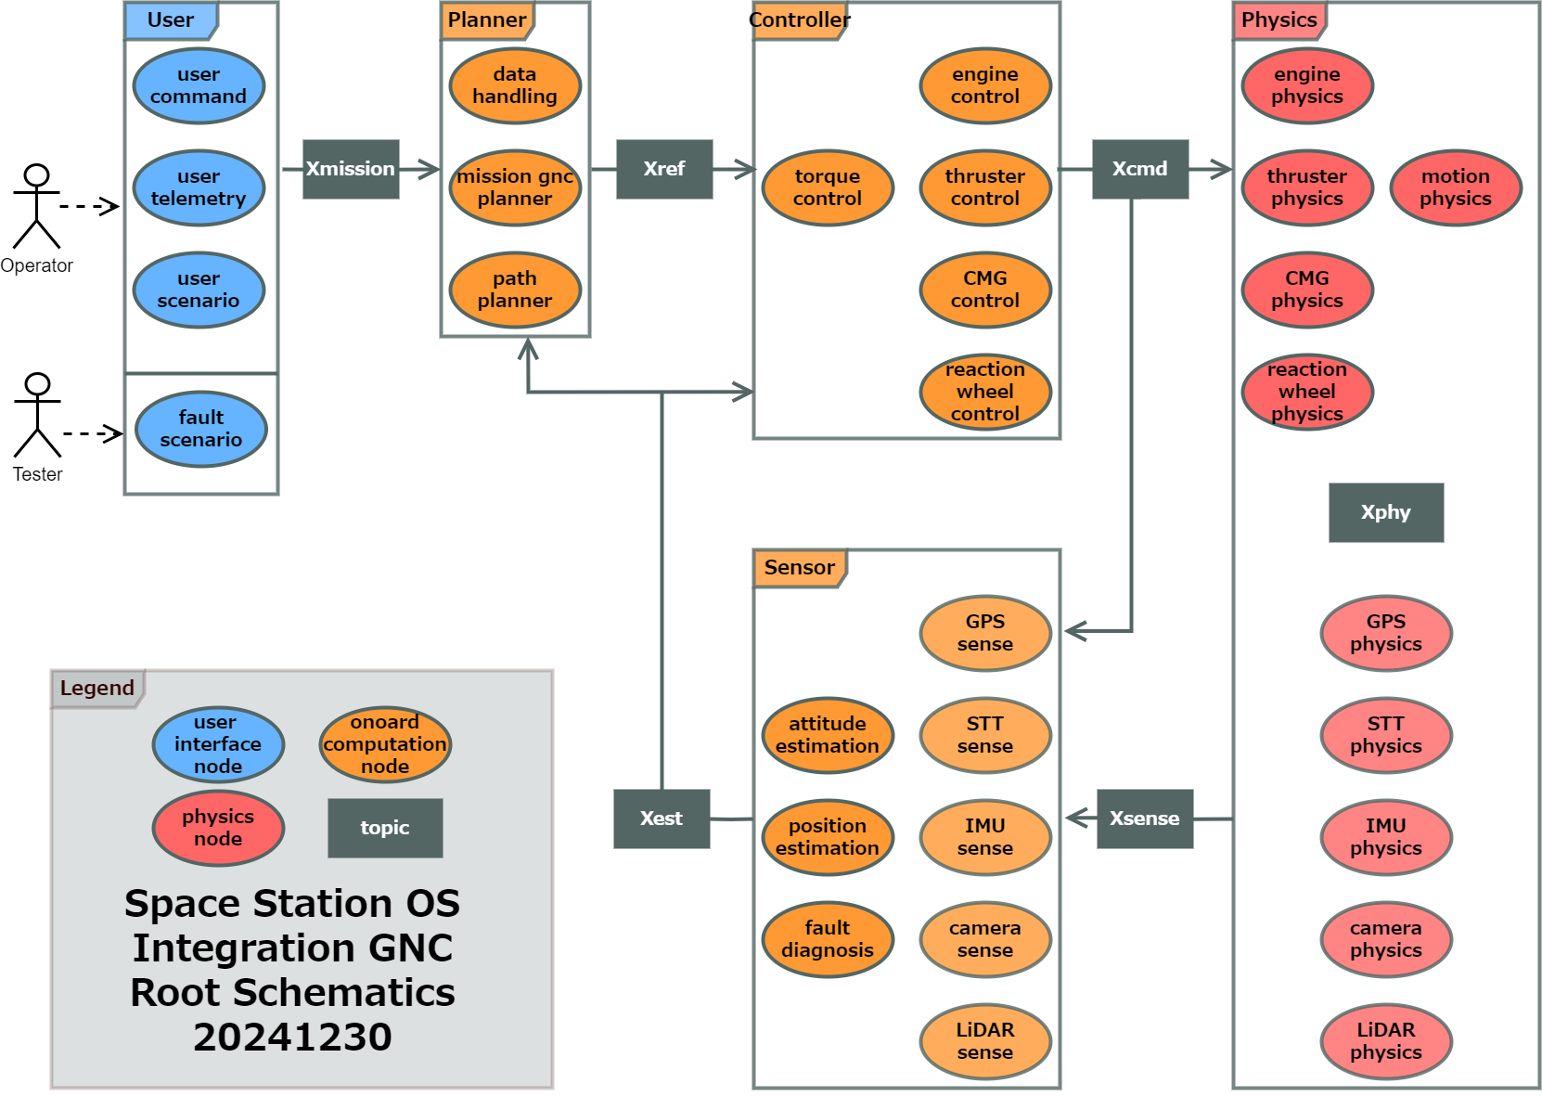

Figure 5.2.1.1 SSOS GNC block diagram

#### I/O design for sub-block

I/O design for each sub-block is shown as below:

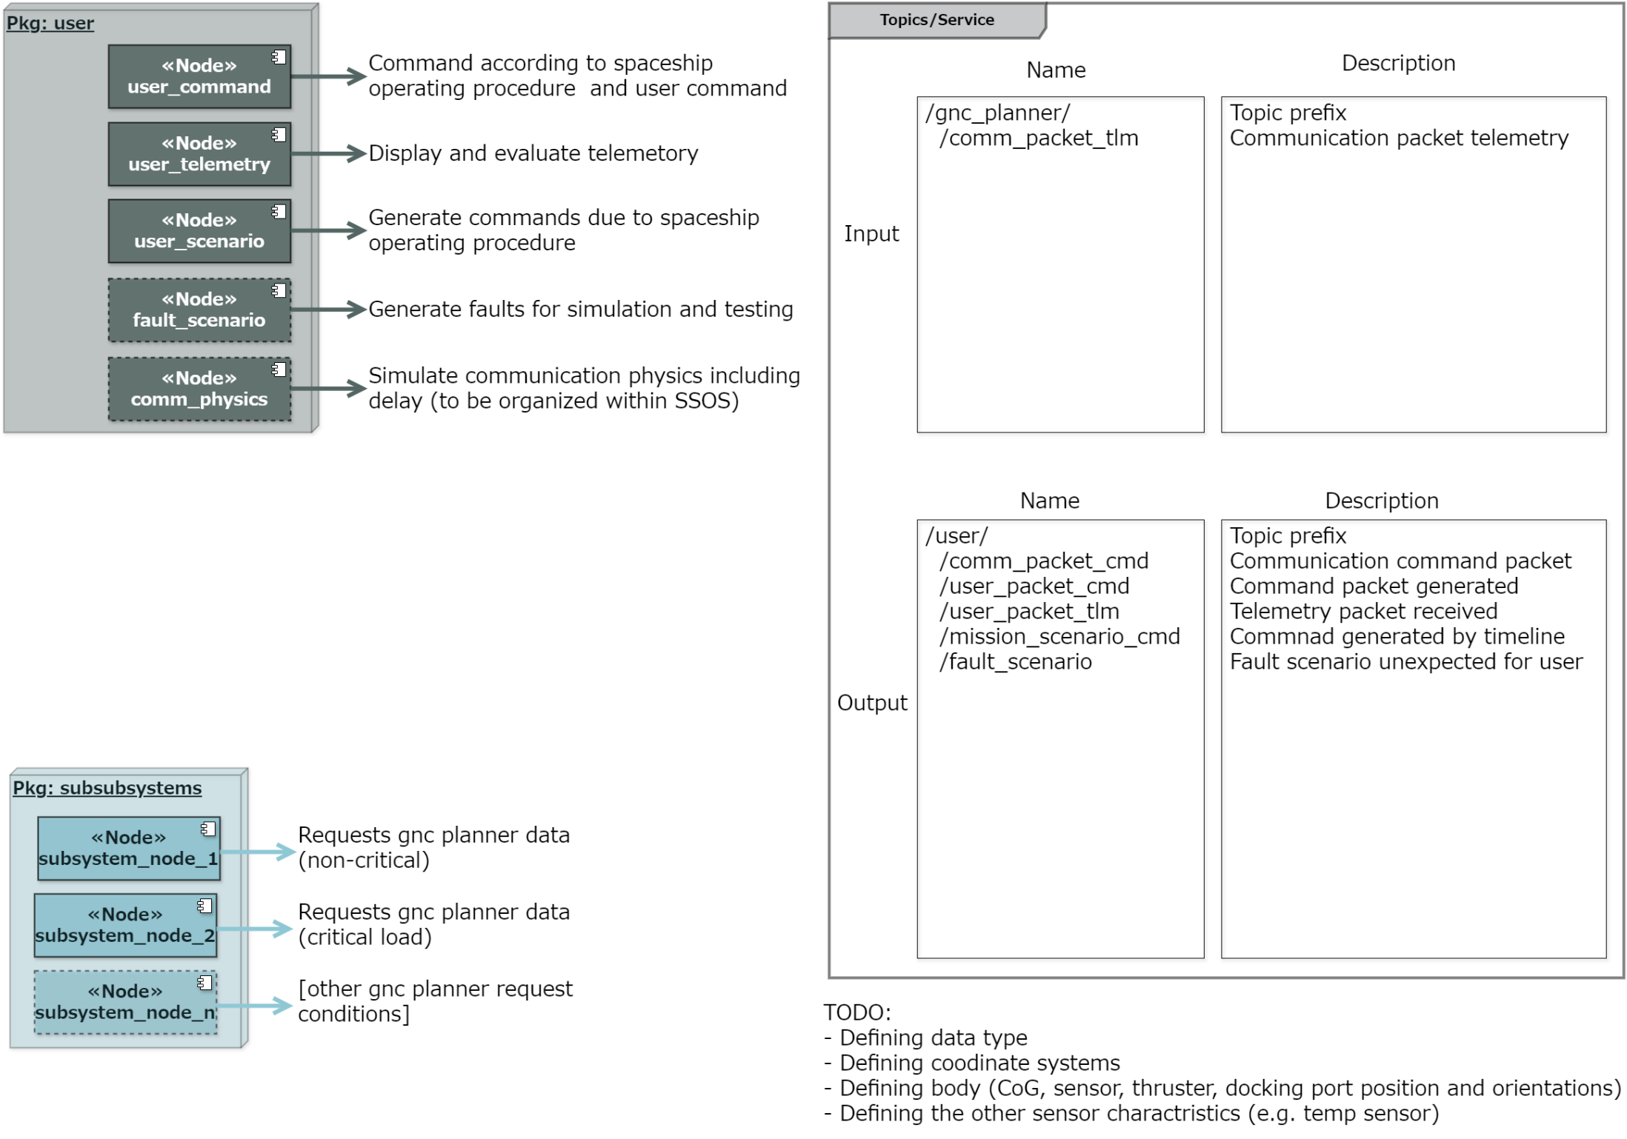

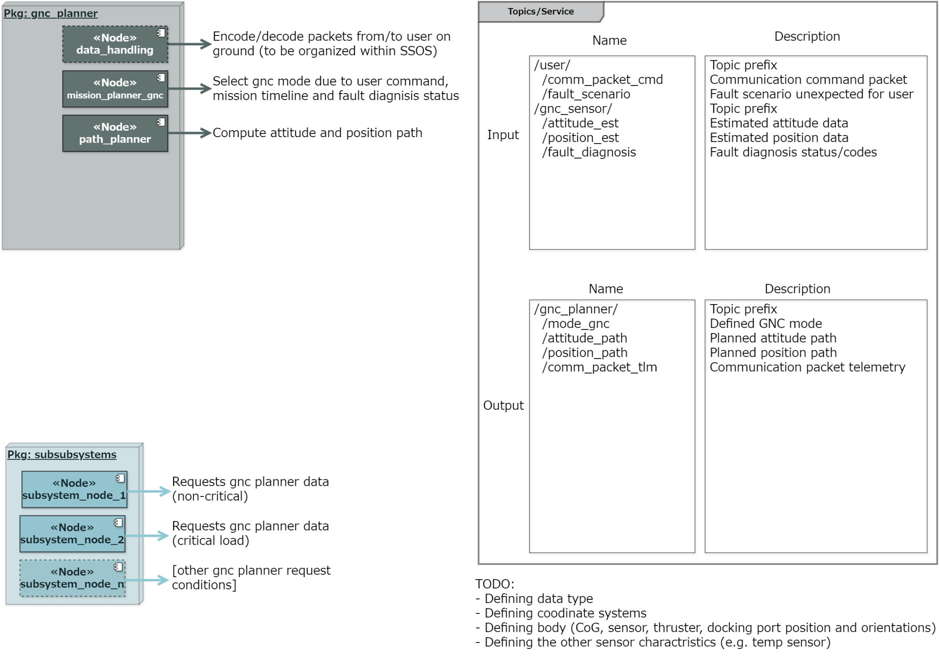

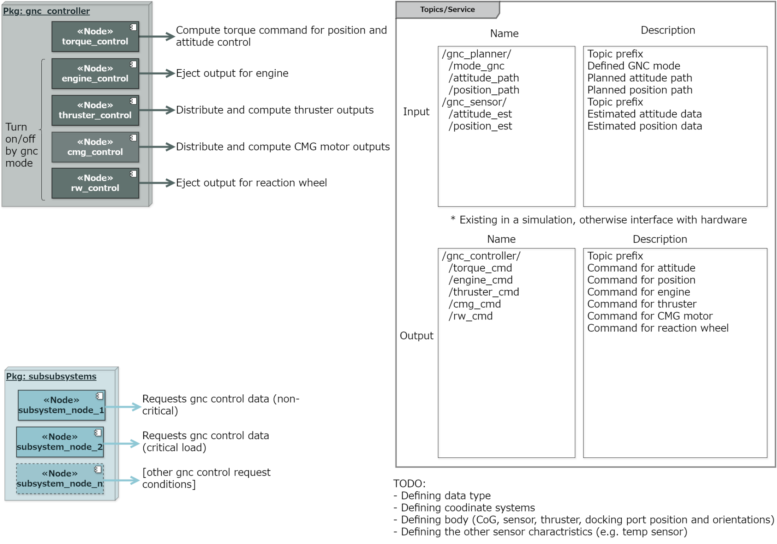

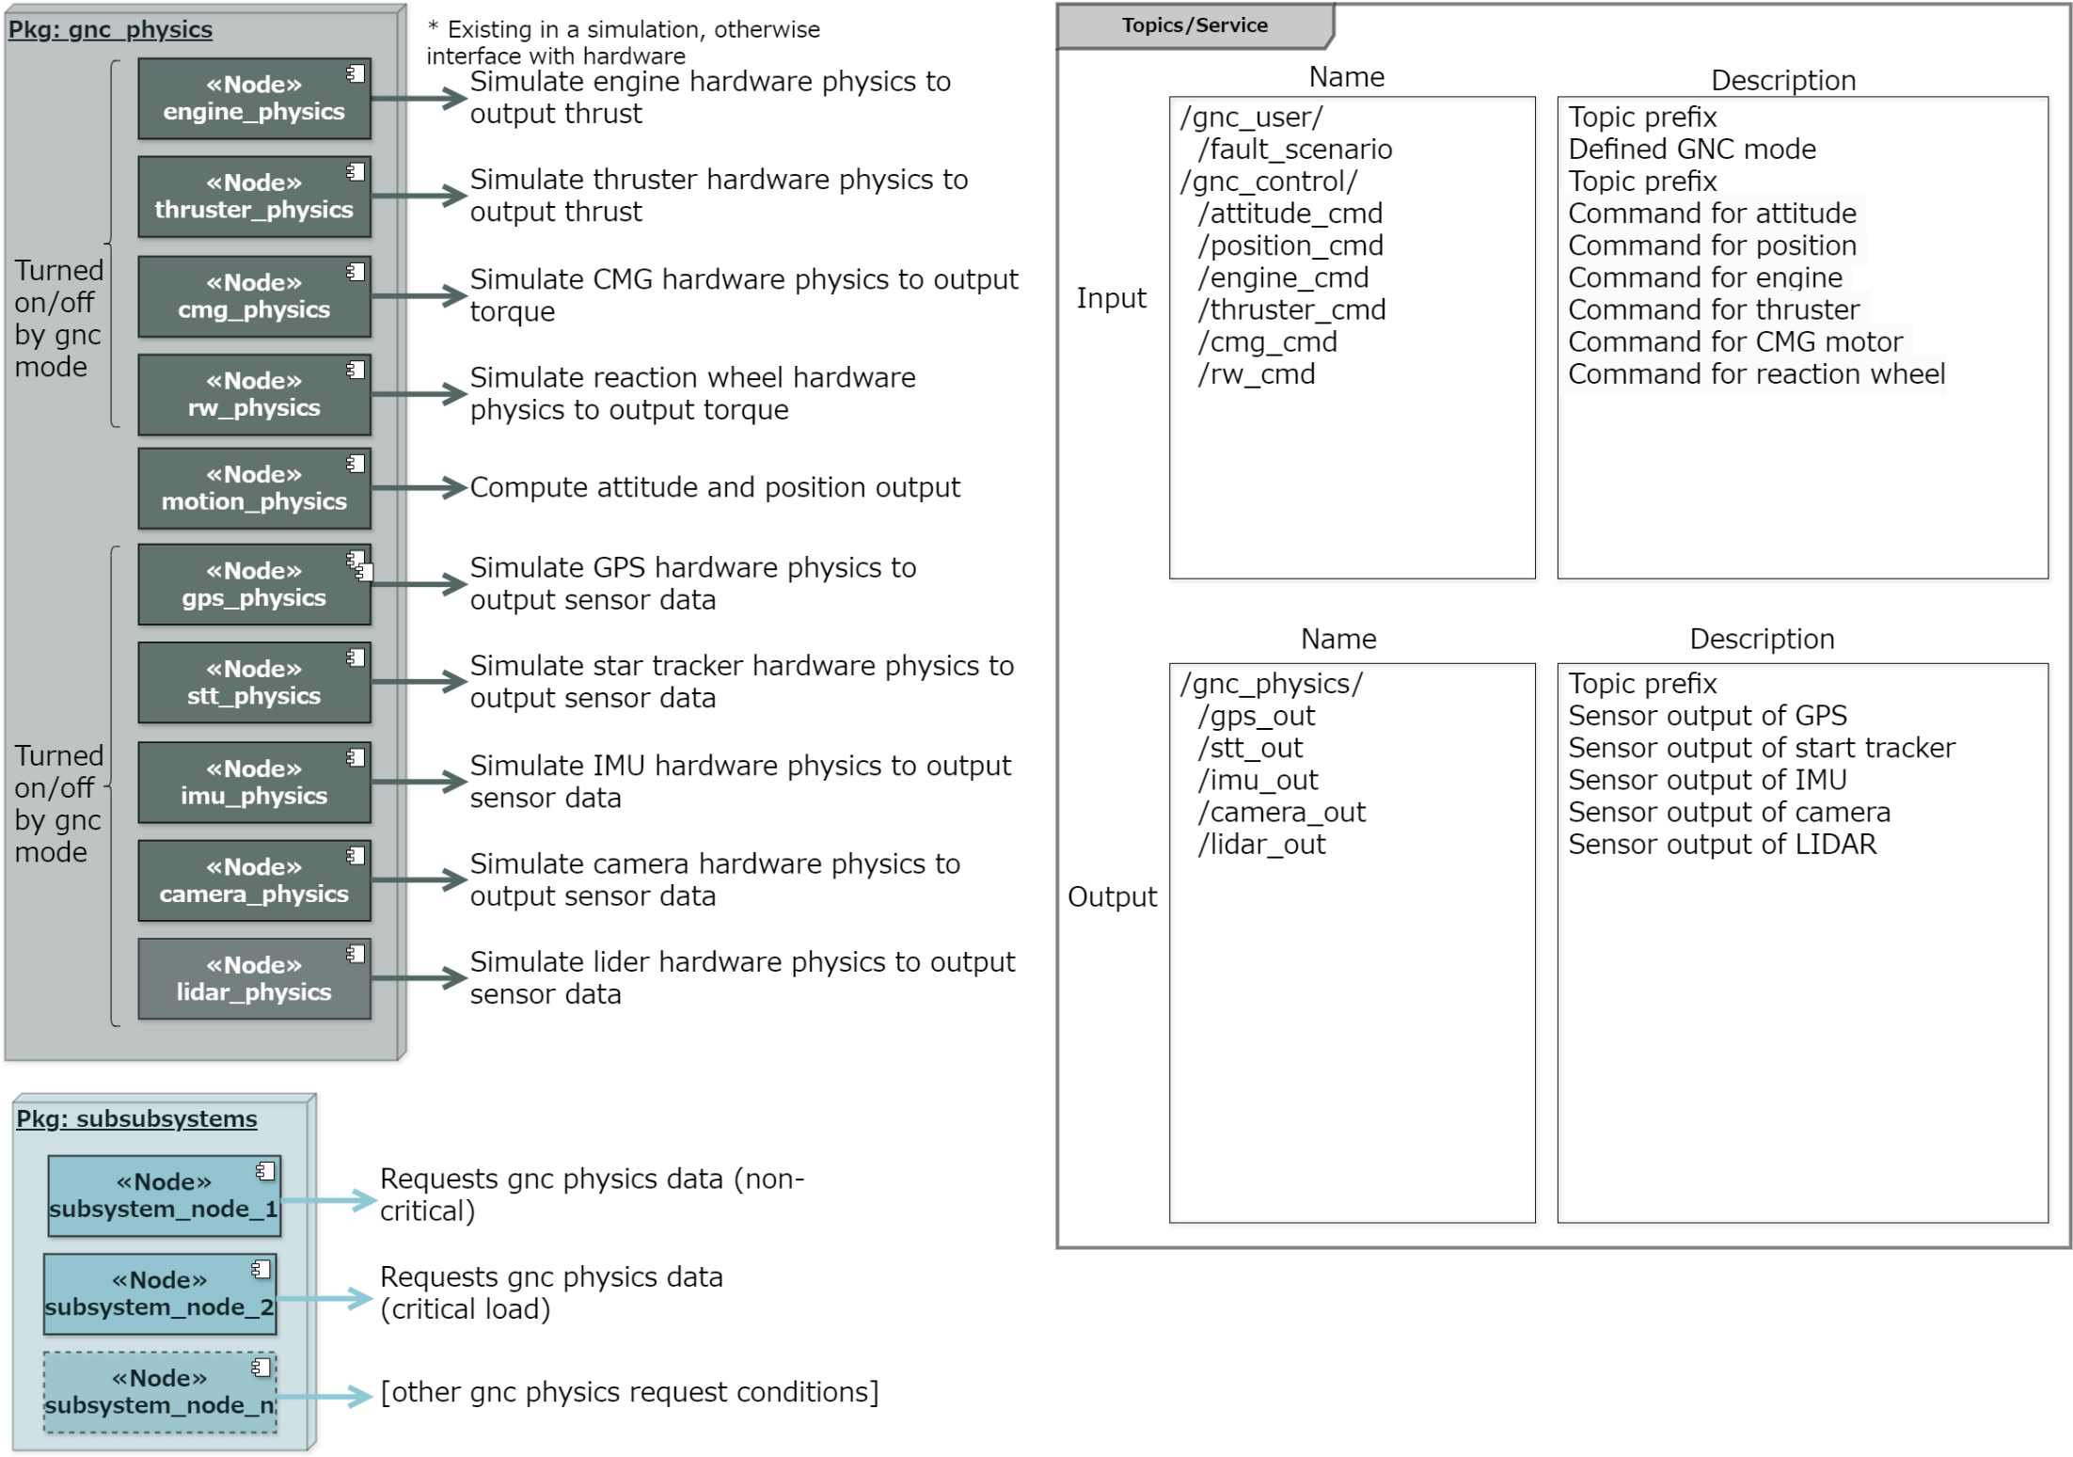

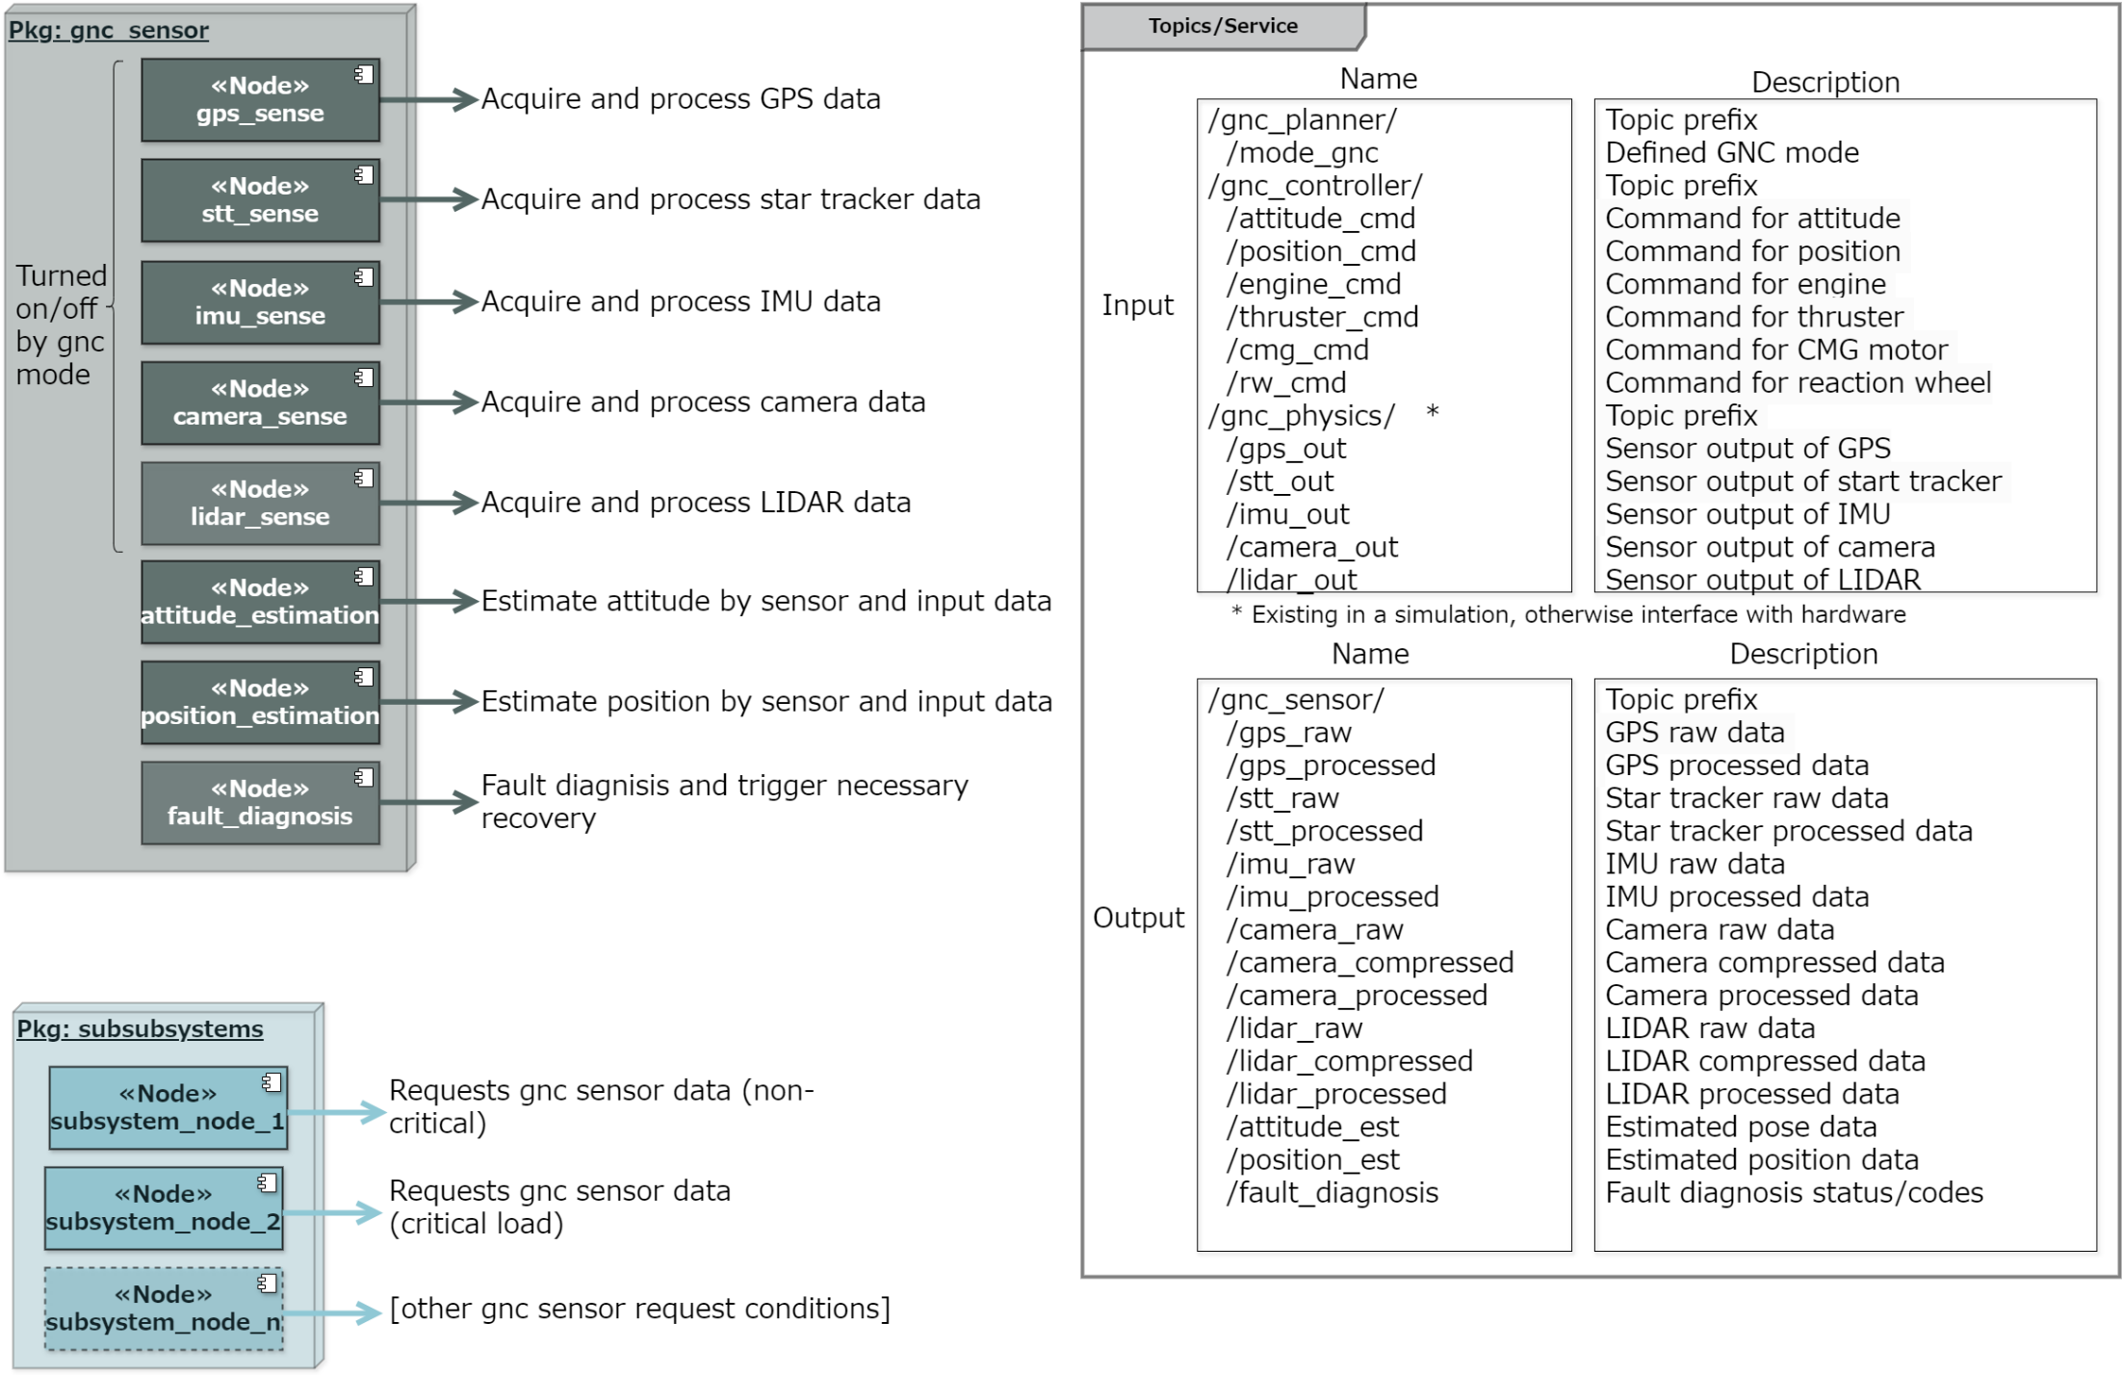

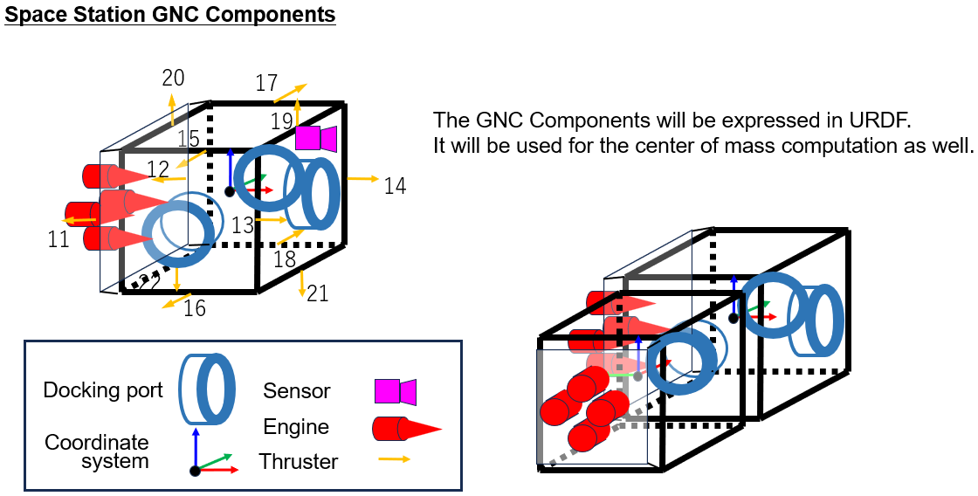

1. TODO:
2. - Defining data type
3. - Defining coordinate systems
4. - Defining body (CoG, sensor, thruster, docking port position and orientations)
5. - Defining the other sensor characteristics (e.g. temp sensor)